Celebrating Simms Historical Analysis Activities

Teacher Information:
This activity works well with SOL USII.1a-d:
- SOL USII.1a-d USII.1 The student will demonstrate skills for historical and geographical analysis and responsible citizenship, including the ability to:
- analyze and interpret primary and secondary source documents to increase understanding of events and life in United States history from 1865 to the present;
- make connections between the past and the present;
- sequence events in United States history from 1865 to the present;
- interpret ideas and events from different historical perspectives;
In this activity, students will read an essay that outlines the entire storyline of the Celebrating Simms exhibit. Following the essay, there is a worksheet containing three sections of activities, including a key terms activity, a timeline activity, and several creative project ideas.

Name:

Celebrating Simms:
The Story of the Lucy F. Simms School

Statement on Purpose of Essay:
This essay is a companion to the exhibit commemorating the contributions of the Lucy F. Simms School and the Northeast Neighborhood to the city of Harrisonburg, Virginia. The essay was written by James Madison University students with help from community members and JMU faculty. The exhibit opened on April 25, 2016, and it is permanently housed in the Lucy F. Simms Continuing Education Center.
This booklet was edited by Brett Seekford and Hannah Jones.
Edited for classroom use by Kailyn Harris-Gilliam.

From Basements to One-Room School Houses

Before the Civil War, traditional education was denied to enslaved African-Americans. However, religious instruction was sometimes tolerated and became a primary gateway for early African-American education and activism. With the permanent ending of slavery, Harrisonburg received aid from the government-sponsor Freedman's Bureau, which established the first schools for African Americans in Harrisonburg in hotel rooms and church basements. After Virginia started a statewide system of public education in 1870, African-American education moved from these informal spaces to dedicated one-room schoolhouses. Sixteen schools for African Americans operated at different times in Rockingham County.

Harrisonburg was more welcoming to African Americans than many of the close-by towns in Rockingham County, making it safer for African-American families to settle down and build a community. The Newmans were early trailblazers in the community. George A. Newman came to Harrisonburg in 1875 as principal of the "colored school" and worked in education for almost 30 years. In 1882, the Effinger Street School opened in Harrisonburg, becoming the primary center for African-American education in Rockingham County until 1938. As the Newtown neighborhood grew around it, Effinger Street School became the center of a tightly-knit community of faith and family.

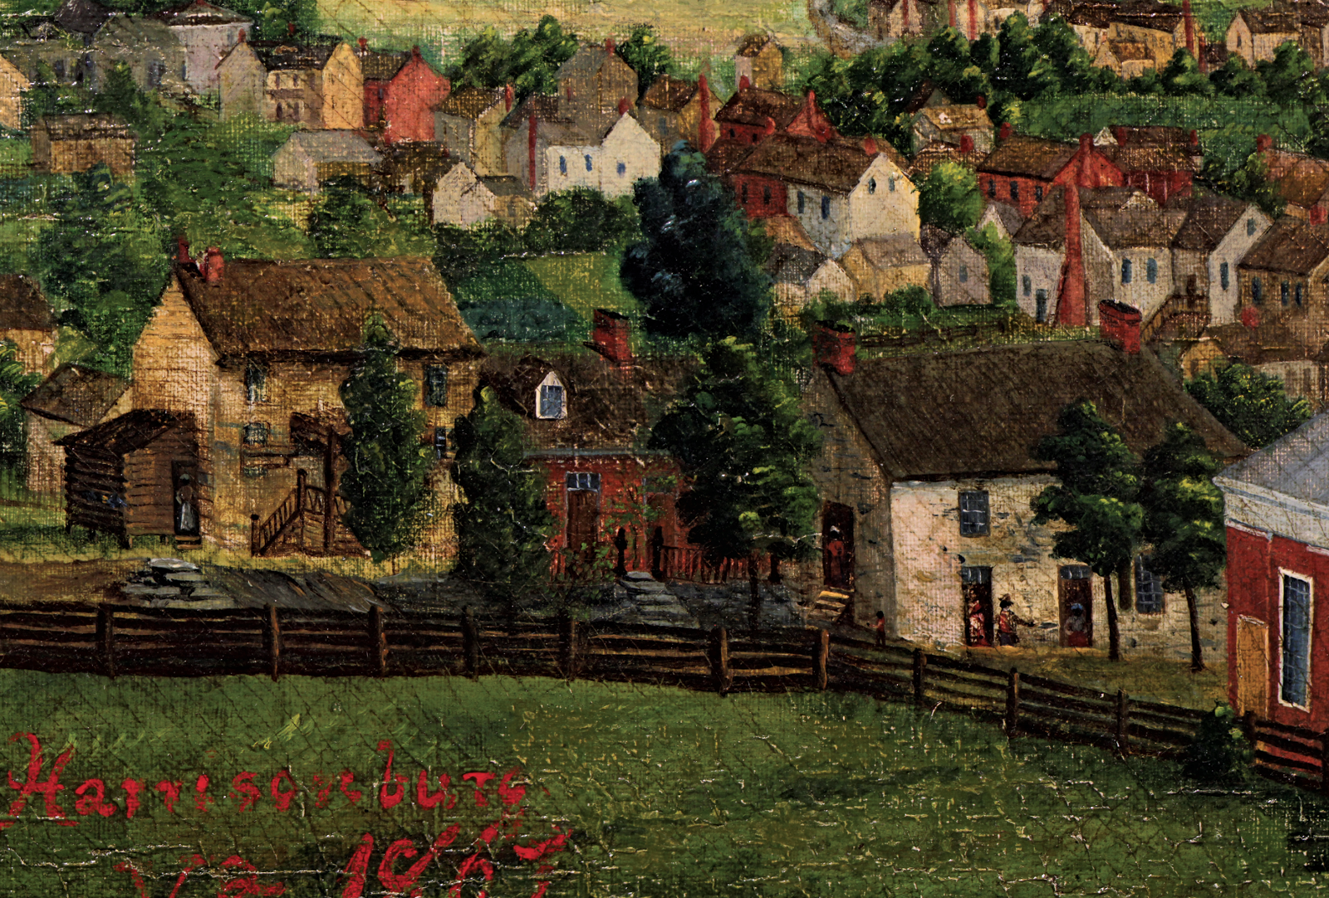1.1

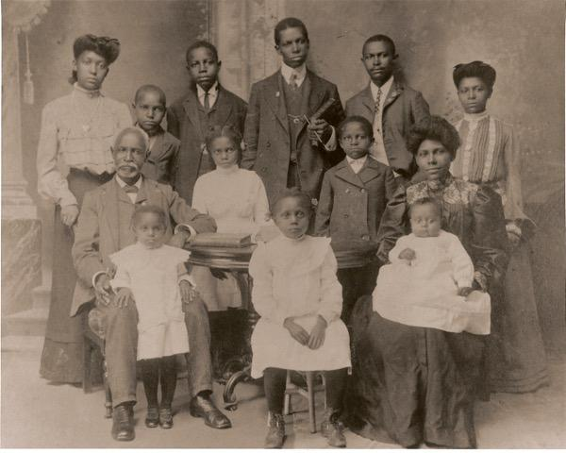
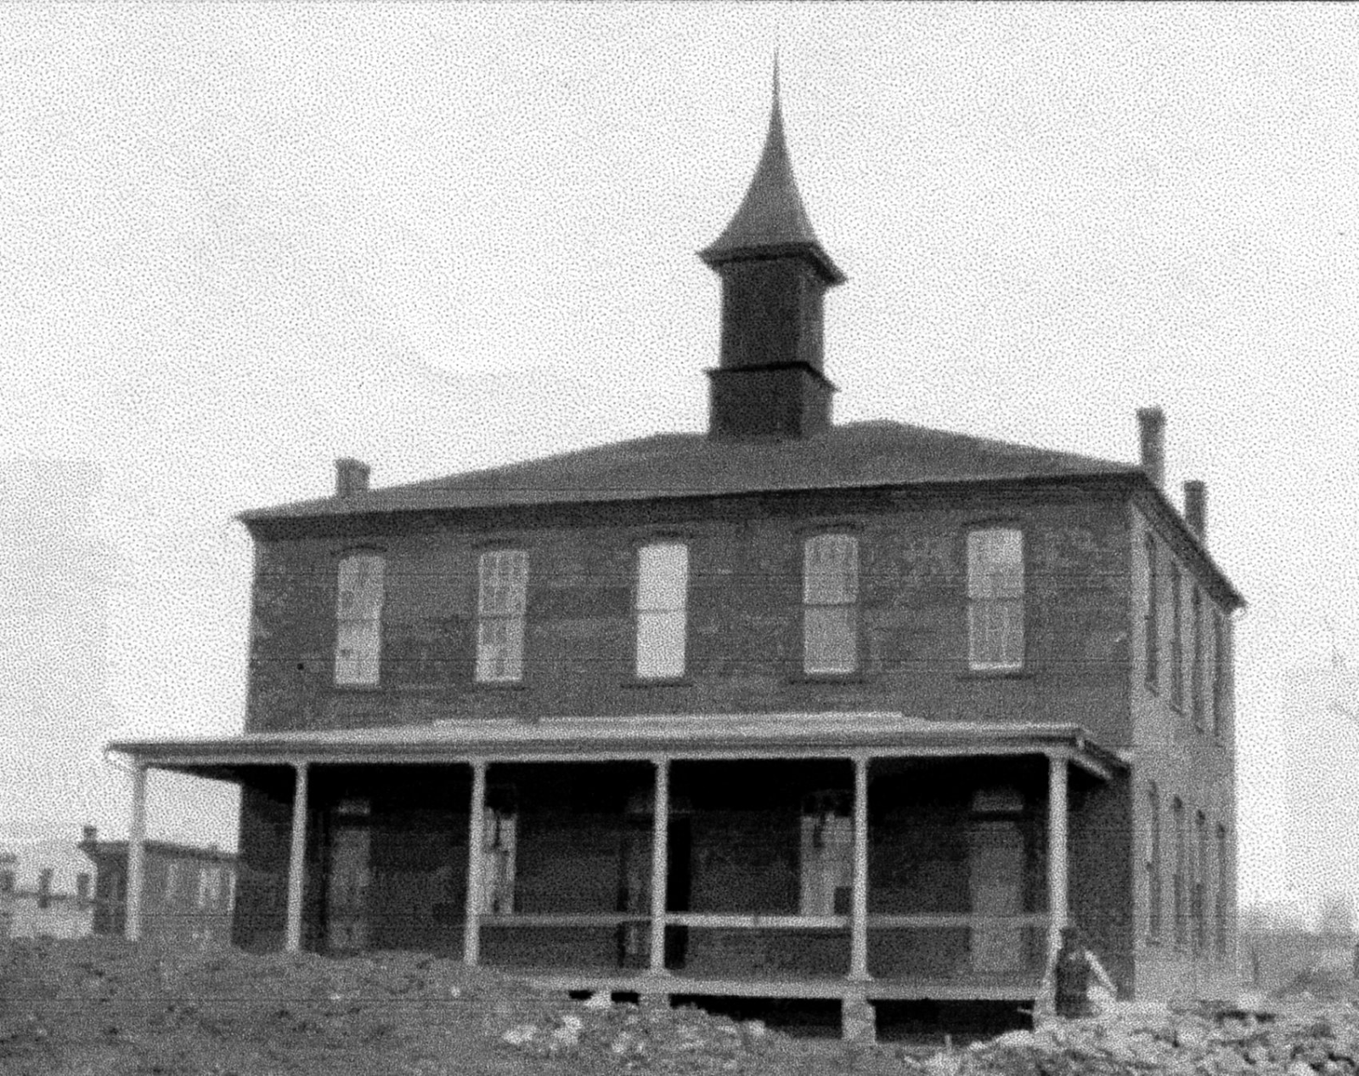1.2 1.3
“So we must rise in self-defense, though humble we may be. And show, by using common sense, that we will still be free.” – George A. Newman
Captions:
1.1 -- Emma Lyon Bryan's painting of Harrisonburg in 1867
1.2 -- Effinger Street School, established in 1882
1.3 -- Photo of George A. Newman and his family, ca. 1903

Lucy F. Simms: Educator, Activist, Leader

At Effinger Street School, educator Lucy F. Simms established a reputation as one of the most famous and important leaders in the history of African-American education in Harrisonburg. Miss Simms was born into slavery in 1856 to the Algernon Gray family. While debate continues over the location of her birth, Miss Simms was living in Harrisonburg at the time of the Emancipation Proclamation. Following her own education at Hampton Institute, where she attended classes with Booker T. Washington, Miss Simms returned to educate the Harrisonburg community.

Lucy F. Simms brought energy and dedication to the three schools where she spent her 56-year teaching career, starting in Athens Colored School (later known as Zenda) in 1877. Eventually the growing number of students prompt the construction of Effinger Street School, where Miss Simms taught for the next 52 years. She is often described as being maternal with her students at Effinger, treating them with kindness, high expectations, and respect.

When Lucy F. Simms died in 1934, her funeral was the most widely attended in the history of African-American funerals in Harrisonburg. Her house, though extensively renovated, still stands at 231 East Johnson St. When the Effinger Street School was finally replaced in 1938, the School Board chose to name the new school in her honor.

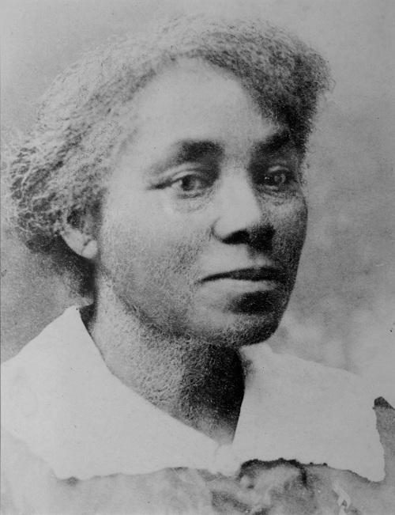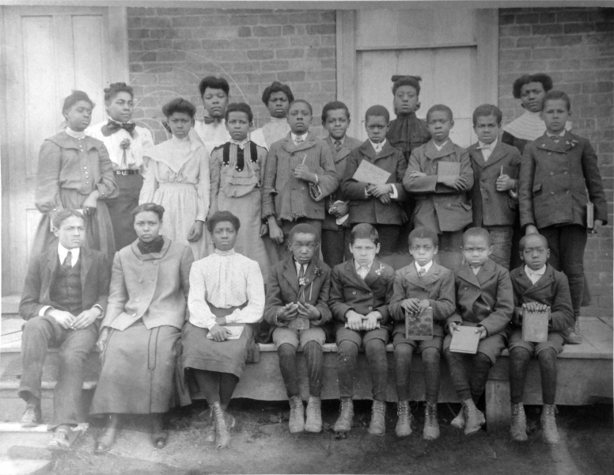
2.1 2.2
“I am teaching and working for my race." -- Lucy F. Simms
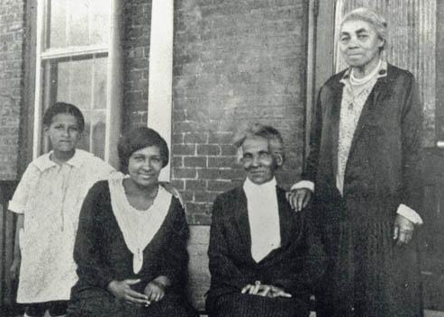
2.3 "When I calculate the time I have been teaching by years, it seems quite a while, but, when I calculate by dollars and cents, it seems but a short while." -- Lucy F. Simms

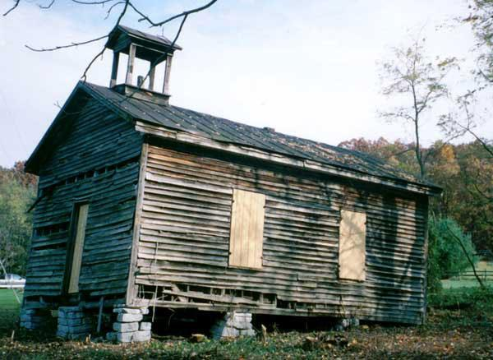
2.4

2.5 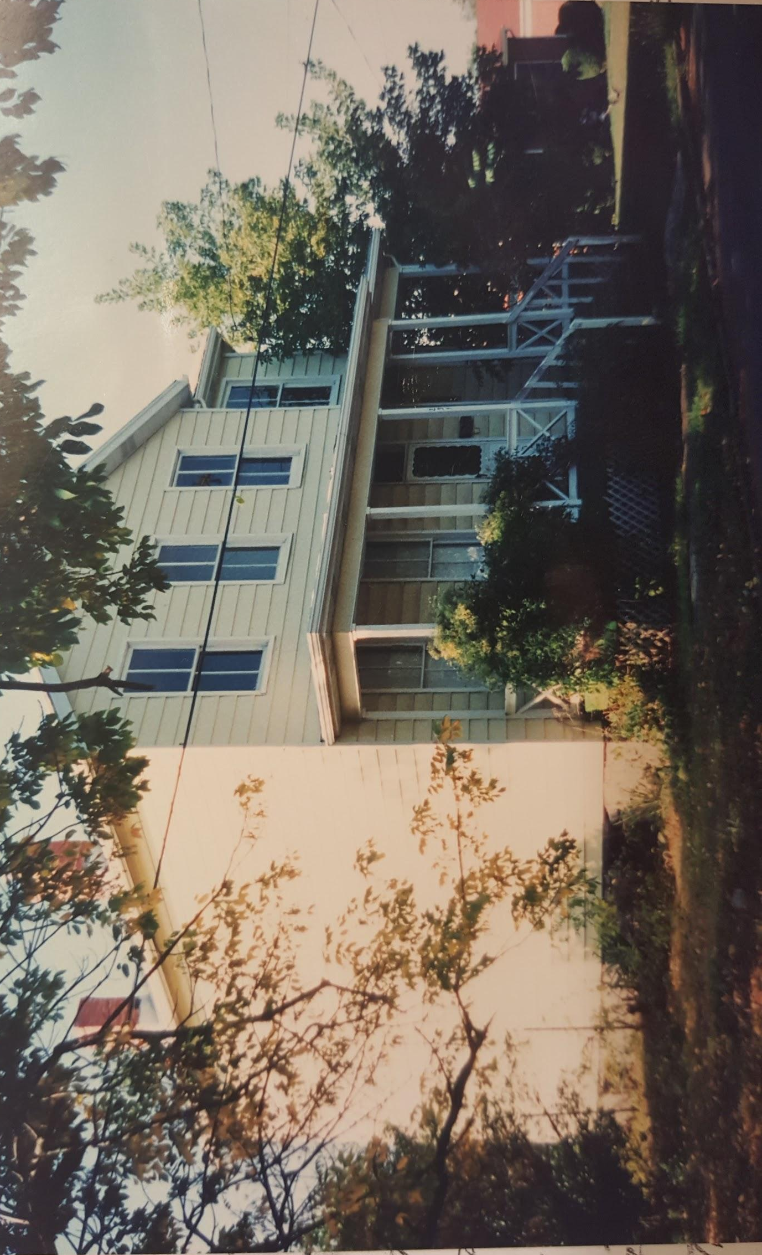

Captions:
2.1 -- Picture of Lucy F. Simms
2.2 -- Lucy F. Simms, second from left, poses with her students in 1905.
2.3 -- Lucy F. Simms stands with three generations of her students in 1928.
2.4 -- A photograph of the Athens Colored School, now known as Zenda, where Lucy F. Simms' early career began
2.5 -- A modern-day image of Miss Simms' home

Learning after Lucy

In 1938, the Lucy F. Simms School was built on the site of the Gray family's former Hilltop estate, drawing students from all over the Shenandoah Valley, with some traveling as many as 50 miles per day. The sense of community and academic rigor that Miss Simms helped to develop in her lifetime continued to flourish at the new school, where parents and teachers worked together to encourage the younger generation's growth and success. For many years, the school did not have the adequate supplies to offer all grades, but by the mid-1950s, students were able to achieve a full high school education. Students not only took classical liberal arts courses such as reading, writing, mathematics, and the arts, but they also completed industrial arts and home economics training to prepare them for the available employment after graduation.

Teachers at the Lucy F. Simms School were well-respected community members who worked hard to make sure their students mastered a wide range of subjects. Mary Francis Awkard Fairfax, Barbara Blakey, and W. N. P. Harris are just a few of the many teachers who positively influenced the lives of their students, teaching skills that extended beyond the classroom. As a result, many Simms students became trailblazers in Harrisonburg and beyond. In 1969, Wilhelmina Johnson became the first African American to be employed by Harrisonburg Social Services. In 1966, Sheary Darcus Johnson became the first African American to enroll at Madison College, graduating in 1970 and earning her Ph.D. from the University of Virginia in 1988.
"The teachers at Lucy F. Simms School knew the needs of the black students and there were always activities going that brought the community together . . .It was all one big, shall I say, family."
-- Ruth M. Toliver

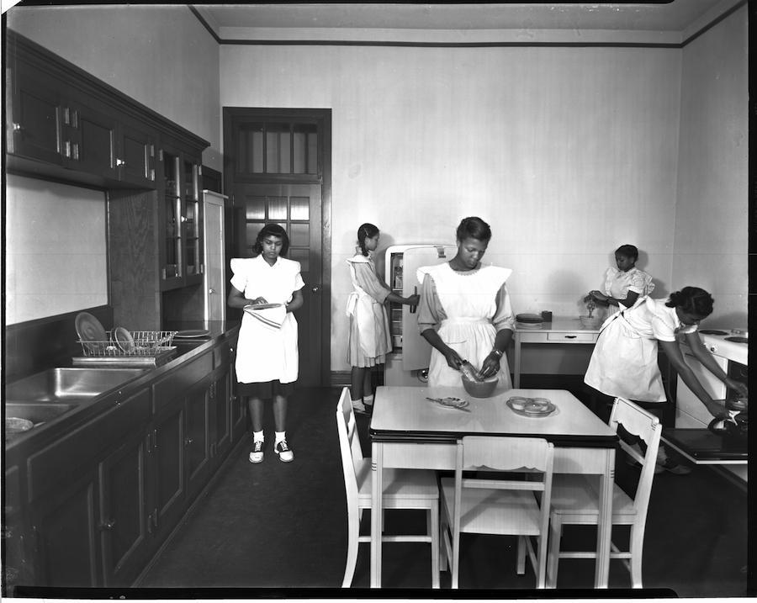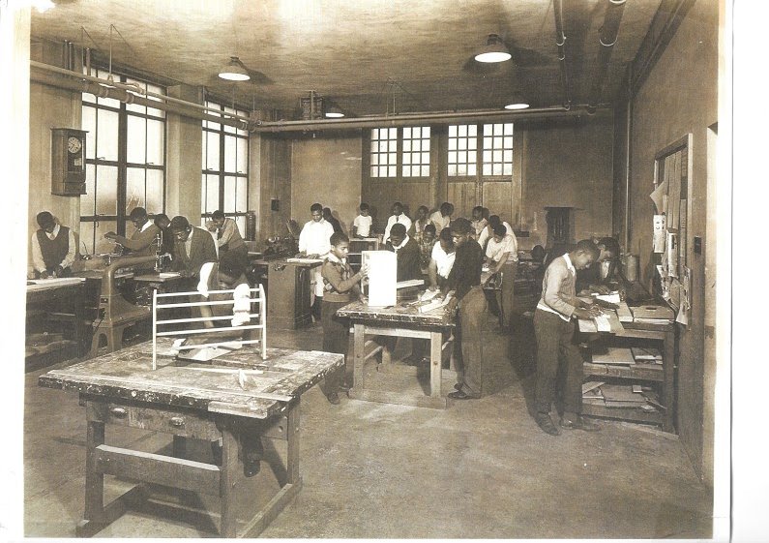
3.1 3.2
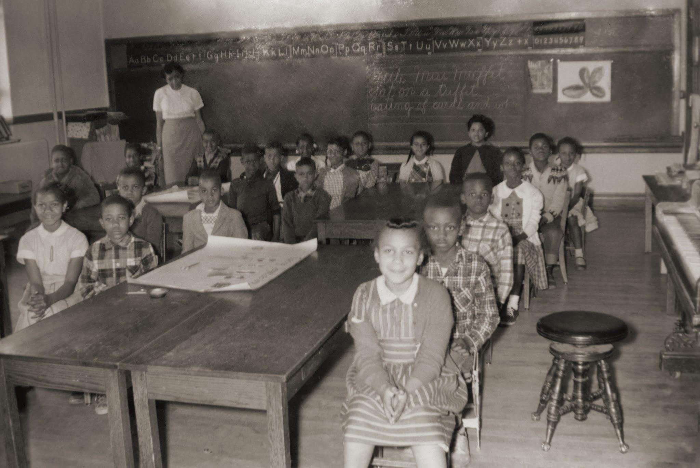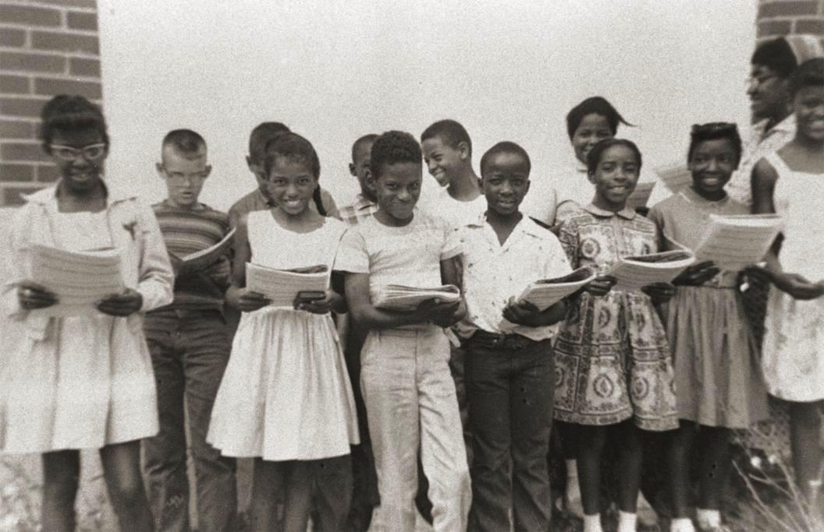
3.3 3.4

Captions:
3.1 -- Students practice new skills in a home economics class
3.2 -- Students work in a shop class
3.3 -- Miss Mary Francis Awkard's class, late 1950s
3.4 -- Students caught singing by the camera

Learning Beyond the Bell

In an effort to create an atmosphere that was as much communal as it was academic, the Lucy F. Simms School sponsored many thriving after-school programs for both students and the Northeast neighborhood as a whole. Athletics, music, and theater represented an important point of contact between formal education and community life in Newtown. The basketball and football teams at Simms won many championship games and were a point of school pride, and groups such as the Bundy's Boys Band and the school choir were loved by everyone.

Operettas were also a rich tradition for many years at the school. The students put on productions varying from the Pied Piper of Hamelin to Peter Rabbit. Parents, as well as members of the Newtown community, would come together to make elaborate costumes for the actors. Mary Awkard Fairfax said the community cared so deeply about these productions that they would "pack the auditorium and people would even sit in the hall.”

May Day was celebrated at the Lucy F. Simms School on May 1st to welcome the arrival of spring. May Day featured a variety of activities such as wrapping the May Pole, a community potluck, the performance of song, dance, and poetry, and the crowning of the King and Queen. It was an important day of celebration and ceremony for the whole community.

4.1

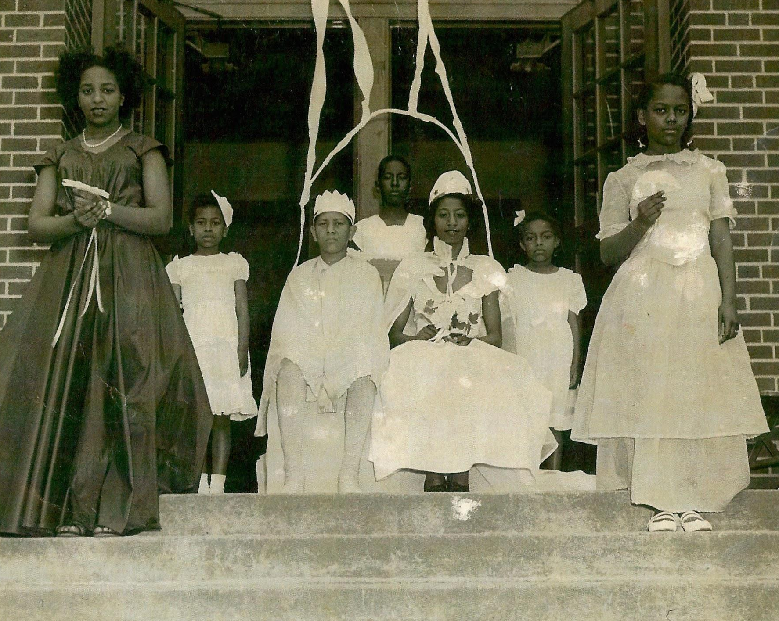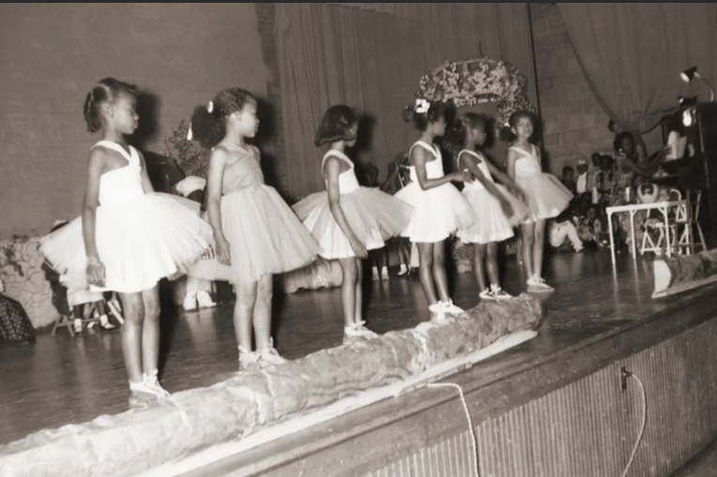
4.2 4.3

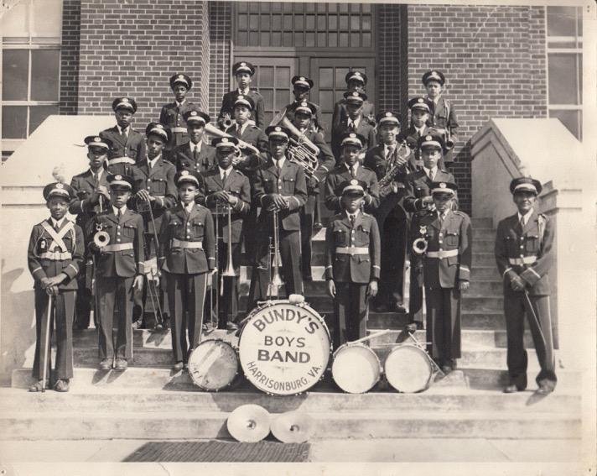
4.4

Captions:
4.1 -- Harry Temple Jr. fighting for the ball in a game played at the Simms gymnasium
4.2 -- A May Day court crowning the king and queen
4.3 -- Young dancers performing in a traditional Operetta
4.4 -- The Bundy's Boys Band, a student-led music group at Simms

Memories of Newtown

"The northeast community joined together in the bitter or the sweetness of our lives."
-Doris Harper Allen

The Lucy F. Simms School was at the center of Newtown, a majority African-American neighborhood with a lively mixture of homes and businesses. Current residents remember it as a place abundant with fruit trees and gardens, bursting with flowers, though missing sidewalks. If you took a walk around Newtown, you would find an ice cream parlor, grocery stores, barber shops, restaurants like Johnson's and the Chicken Shack, and the famous Colonnade, where there was a pool hall, a dance hall, and an arcade. Most Newton's social gatherings happened in homes around the neighborhood, and festive lawn parties were often held in people's yards. Lawn parties were known for their bright string lights, singers, homemade ice cream, country ham sandwiches, and good company.

The local churches were also an important part of community life. Ladies, gentlemen, and young children all arrived in their Sunday best, walking from all over town to attend services. For many African American residents, Sunday was an important day for the community.

Reflecting on her time in Harrisonburg and the Northeast neighborhood, Ruth M. Toliver says her "fondest memories of growing up" are "memories of Harrisonburg. . . . It was just one of those communities where you felt safe."

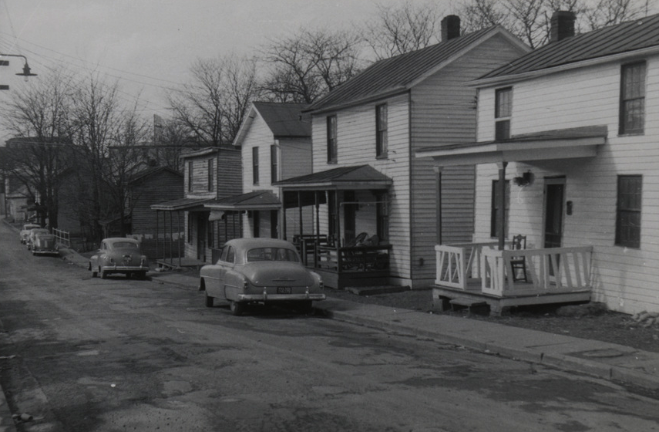

5.1
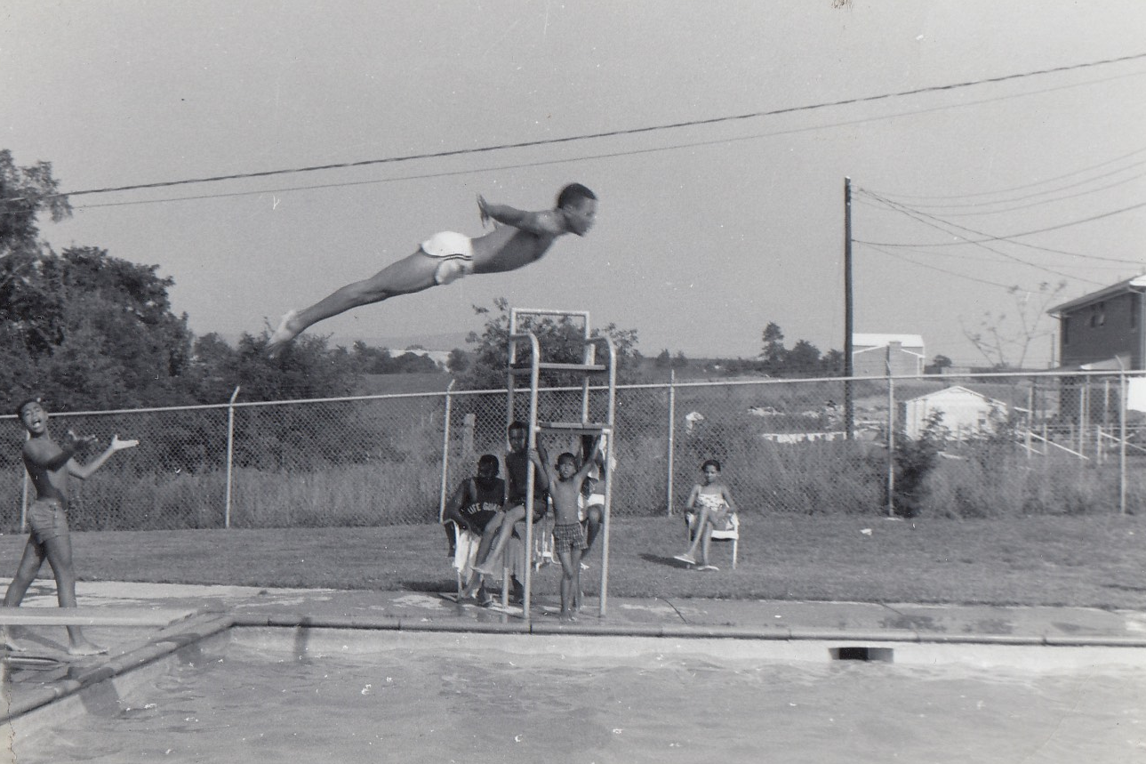
5.2

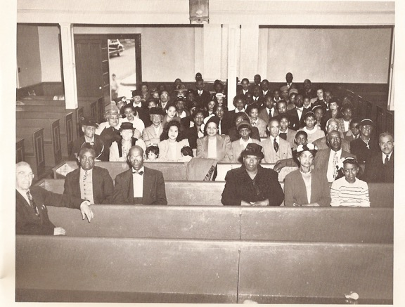
5.3
Captions:
5.1 -- Image of Effinger Street
5.2 -- Kids spend time at Harris Pool
5.3 -- First Baptist Church Congregation, ca. 1950s

Miss Lucy's Legacy

At the end of the 1965 school year, Lucy F. Simms School closed as a part of national school integration. Many teachers at Simms lost their jobs during the transition, although teachers like Mary Awkard Fairfax and Barbara Blakey went on to teach in integrated schools. While African Americans in Harrisonburg and across the country were granted greater educational opportunities, many of them felt they lost a sense of community as a result of integration.

"They lost the school. And it has never been the same." --Mary Awkward Fairfax

The school building was left officially vacant for many years after its closing, but several members of the Northeast neighborhood would later establish a reunion committee to bring former classmates back together. Their first reunion was held in 1982. These efforts began the process of reuniting past friends and neighbors.

The Lucy F. Simms Continuing Education Center was founded in 2005 after extensive renovations and community encouragement. It now supports after-school and community organizations that use its gymnasium, computer labs, and conference rooms. As the home for many community events such as the Gospel Extravaganza and the Martin Luther King, Jr. Breakfast, the center continues to be a very important part of the community.

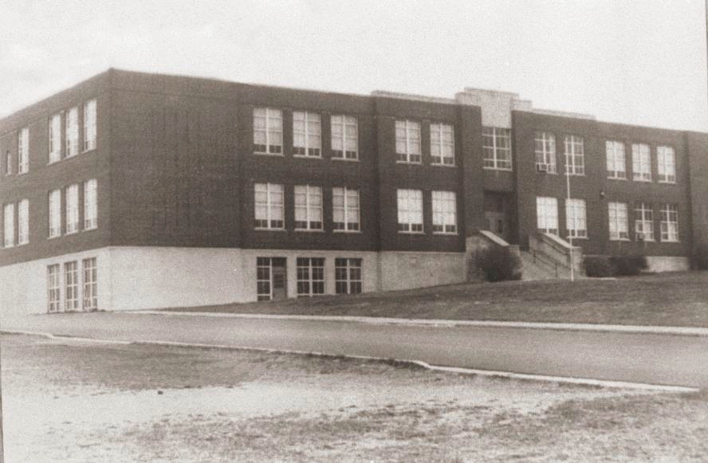
6.1

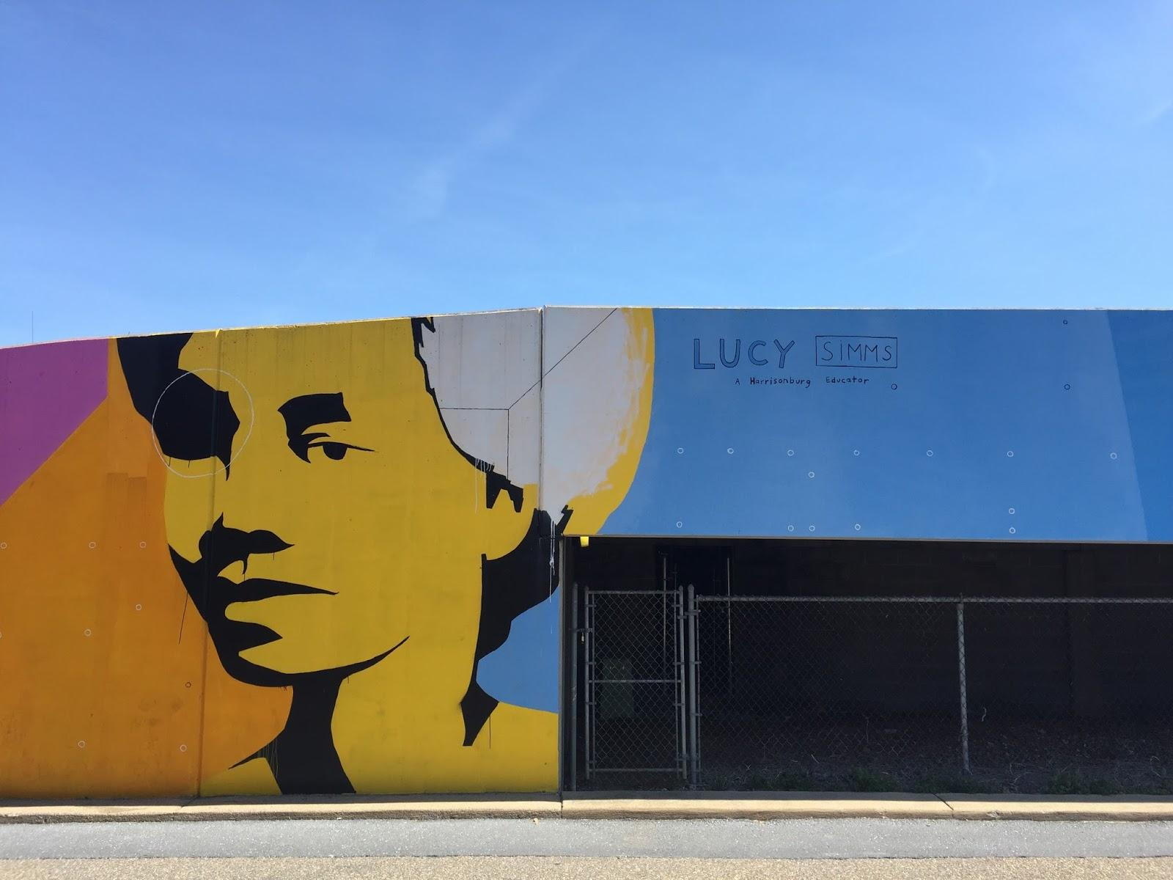6.2

Captions:
6.1 -- Include this quote in upper right: "They lost the school. And it has never been the same." --Mary Awkward Fairfax (Quote 6)
6.2 -- Just quotes from link as they appear there

Celebrating Simms:
The Story of the Lucy F. Simms School

Directions:
Step 1: Read through the essay “Celebrating Simms: The Story of the Lucy F. Simms School”. While reading through the essay, highlight key-terms that have been studied in class, such as terms about post-slavery, laws, and more. In addition to highlighting key-terms, underline or circle terms that you do not understand.
Step 2: This worksheet corresponds to the given essay. There are three sections. Directions will be listed for each section.

Section 1: Matching
Founded in 2005 after extensive renovations and community encouragement. It now supports after-school and community organizations that use its gymnasium, computer labs, and conference rooms.

This was celebrated at the Lucy F. Simms School on May 1st to welcome the arrival of spring. May Day featured a variety of activities such as wrapping the May Pole, a community potluck, the performance of song, dance, and poetry, and the crowning of the King and Queen.

In 1882, this school opened in Harrisonburg, becoming the primary center for African-American education in Rockingham County until 1938. The principal here was George A. Newman.

___ 1. Freedman’s Bureau

___ 2. Effinger Street School

___ 3. Emancipation Proclamation

___ 4. Lucy F. Simms

___ 5. Athens Colored School (Zenda)

___ 6. May Day
d. an agency of the War Department set up in 1865 to assist freed slaves in obtaining relief, land, jobs, fair treatment, and education.
e. Born into slavery and freed after the Emancipation Proclamation, she went on to study at Hampton Institute. She taught in the Valley for 56 years. She is known as one of the most famous and important leaders in African-American education in Harrisonburg, VA.
f. This was a rich tradition for many years at the school. The students put on productions varying from the Pied Piper of Hamelin to Peter Rabbit. Parents, as well as members of the Newtown community, would come together to make elaborate costumes for the actors.
g. School where Lucy F. Simms started her teaching career
h. the declaration issued by President Lincoln on January 1, 1863, freeing the slaves in those territories still in rebellion against the Union.
i. a majority African-American neighborhood with a lively mixture of homes and businesses. Current residents remember it as a place abundant with fruit trees and gardens, bursting with flowers, though missing sidewalks.
j. having, including, or serving members of different racial, religious, and ethnic groups as equals

____ 7. Operettas

____ 8. Newtown

____ 9. Integration

____ 10. Lucy F. Simms Continuing Education Center
Section 2: Timeline
Directions: Using the information from the essay, in groups, create a timeline comparing the African-American history of education in Harrisonburg, VA to national changes and issues in the United States of America. Below is a key of events that should be included on your timeline. You are NOT limited to these options and you MUST add more events that are not included on this list.
Key Terms or Events:
- Lucy F. Simms School
- Athens Colored School (Zenda)
- Effinger Street Schools
- Emancipation Proclamation
- Freedman’s Bureau
- Integration

Section 3: Creative Project
Directions: This last activity allows you to get your creative juices flowing. You have three creative options you can choose from:
- Be A News Reporter: Write a newspaper article about Lucy F. Simms or about the history of the Lucy F. Simms School. Using the essay and the Celebrating Simms website, create an article that details the history, facts, and information about either Simms as an educator or about the historic school in general.
- Create an Exhibit: Using the information learned from the essay and website, create a small scale exhibit about the history of the African-American heritage in Harrisonburg, VA. The exhibit should include pictures, facts, and fun info that you have learned during this unit.
- Be a Movie Director: Using iMovie, create a movie trailer about the African-American history in Harrisonburg, VA. The trailer, though fairly short, should include pictures, facts, and valuable information about the history and heritage of African-Americans in Harrisonburg, VA.

