Lucy F. Simms Map Quest Activity

Teacher Information:

This activity works well with SOL VUS.1d.

- SOL VUS.1d. The student will develop perspectives of time and place, including the construction of maps and various timelines of events, periods, and personalities in American history.

In this activity students will use the Celebrating Simms exhibit and other websites and resourses to locate and describe specific places on a map of Harrisonburg that are important when learning about African American history in Harrisonburg.

Student Directions: Students are to use the websites and “Routes to Simms” slide to record what each location represents and write a short description using the information that they find. The answers to the worksheet are as follows:

From Local History Website:
- Simms Continuing Education Center (formally Lucy F. Simms school)

From Story Map Harrisonburg:
- Effinger Street School
- Lucy F. Simms Home
- Roberta Webb Child Care Center
- First Baptist Church of Harrisonburg
- Jail Hill

From “Roads to Simms” slide:
- Mount Jackson Bus Stop (25 Miles away)
- Bridgewater Bus Stop (8 Miles away)

Descriptions about each location will vary.

Map Quest Activity

Using the websites and resources, find which location the numbers on the map represent and what their relation is to African American history in Harrisonburg:

Resource: | Name of Location: | Description:
Local History Website:  (http://localhistory.rockingham.k12.va.us) | 1. | 1.
Celebrating Simms Interactive Map:  (https://omeka.lib.jmu.edu/simms/storymap) | 2.  3.  4.  5.  6. | 2.  3.  4.  5.  6.
Road To Simms Slide:  (Found in Celebrating Simms exhibit, and on the Celebrating Simms Website:  (https://omeka.lib.jmu.edu/simms/celebrating-simms-exhibit, slide 19) | 7.  8. | 7.  8.

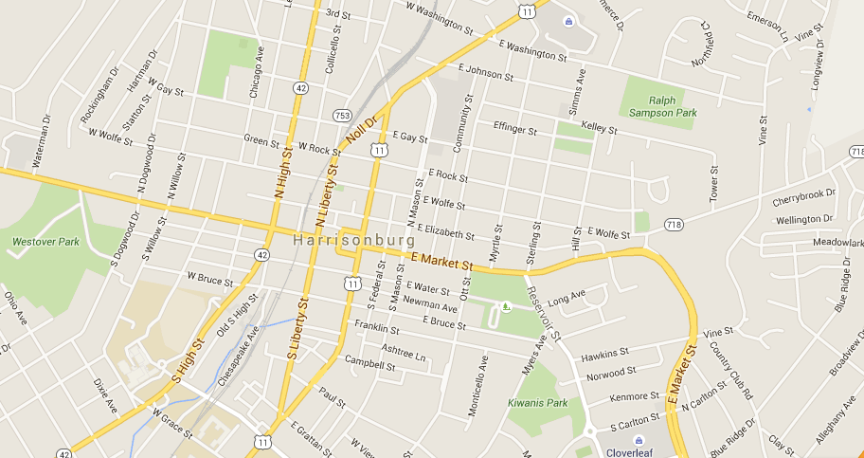
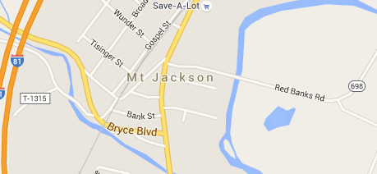
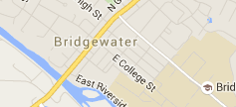

1.
2
3
4
5
6
7
8

